Table of Contents

Lab 1 - Sorting 1

Data 2

Solution: Sorting. 3

# Lab 1 - Sorting

Objectives

Sorting

Practice: Sorting

A computed sort sets the sort order option and changes dynamically as the data changes. There are several types of computed sorts.

**To Use a Default Sort**

1. In the Data pane, right-click the dimension to sort on.
2. On the context menu, select Default Properties, and choose Sort.
3. In the Sort dialog box, choose Manual, and then use the Up and Down buttons to manually sort the dimension members.
4. Click OK. The sort order is part of the field properties of the dimension, and can be used across worksheets in the workbook.

**To Use Right-Click Sorting on a Dimension**

1. In the View, right-click the dimension to sort.
2. On the context menu, choose Sort. The Sort dialog box appears.
3. Set the sort order (Ascending or Descending).
4. Set the Sort by option, and click OK.

**To Use One-Click Sorting on an Axis**

On the toolbar, click either the Ascending or Descending sort icon. If you hover, a tooltip appears that describes how the sort will be performed (based on fields in the view, and current view selections).

**Manual Sorts**

**To Use Drag and Drop Sorting**

1. On the View, select the headers or labels for the items you want to sort.
2. Drag the selected headers or labels to re-order them.

To Sort on Selected marks

1. On the View, select the marks for the dimension members you want to sort.
2. Hover until the Tooltip displays, and then choose either Sort Ascending or Sort Descending.

Open *.twb and modify the view on the View One tab according to the following specification:

View One

Uses a manual default sort for Category in this order: **DAL** is first, then **NYC**, and then **BOS**.

Uses a local sort in the view to order Sub-Category by **SUM(All Determinations)** in descending order.

**Directions**

1. On the View One worksheet, create a manual Default Sort for Category, with values ordered by **DAL** is first, then **NYC**, and then **BOS, leave** other by default.
2. On the View One worksheet, sort Sub-Category by **SUM(Determinations)** in descending order.
3. Duplicate the View One worksheet to create a View Two worksheet.
4. On the View Two worksheet, color encode the bars by Profit, and edit the color pallet to Orange-Blue Diverging.
5. On the View Two worksheet, edit the sort applied to Sub-Category so Field selected is sum of Profit.

## Data

This documentation describes a publicly available dataset containing historical and current information about the processing by the Social Security Administration (SSA) of initial claims for disability benefits.  The dataset includes information from federal fiscal year 2001 onwards concerning initial claims for disability benefits that were referred to a [state agency](https://www.ssa.gov/disability/data/ssa-sa-fywl.htm#StateAgency) for a disability determination.

  Specific data elements for each state are receipts, determinations, and the number of determinations which were allowances.  Additional data is present allowing the calculation for separate eligible adult and child populations their respective SSA benefit receipt rate, disability application filing and allowance rates, and percent of claims with a favorable disability determination.  This data may be used to examine disability application filing trends by time and by state, state agency workloads, and disability claims outcomes.

A dataset containing fiscal year data can be downloaded from: <https://www.ssa.gov/disability/data/SSA-SA-FYWL.csv>.

### Solution: Sorting.

View One

1. Open **\Tableau\Labs\Lab 1 - Sorting and filtering\Sorting_Starter.twb.**

2. In the view, right-click the **Region Code**, and choose Sort.

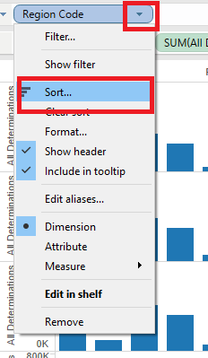

1. In the Sort dialog box under Sort by, choose **Manual**.
2. To set the sort order, drag and drop each field, or, select a field and use the Up and Down buttons. Order them so **DAL** is first, then **NYC**, and then **BOS**, and then click OK.
3. Come back to the Sort dialog box under Sort by, choose **Field**.

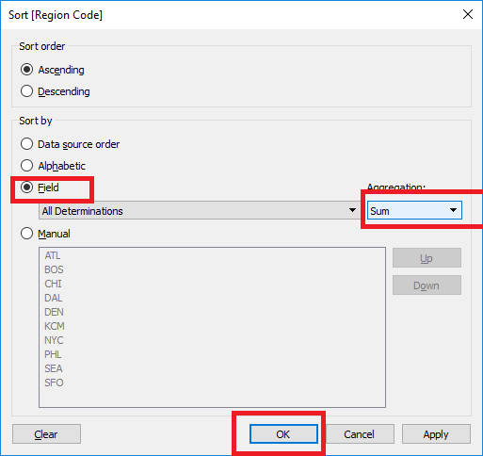

1. Hover on the **Date ID,** and click the Sort icon  to toggle between ascending and descending sort. Leave it as descending sort.

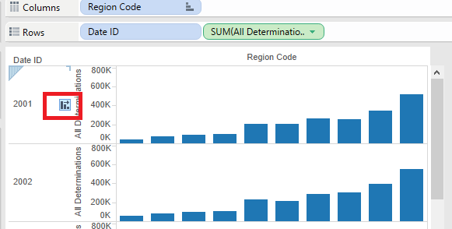

**View Two 1. Right-click the View One worksheet tab, and then click Duplicate Sheet**

2. Right-click the Sheet 2 worksheet tab, click Rename Sheet, type "View Two" and press the ENTER key.

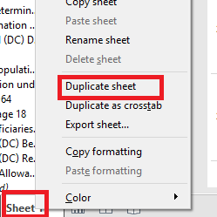

1. From Measures, drag **All Determinations** to Color on the Marks card.

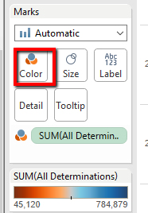

4. On the **SUM(All Determinations)** legend, click the drop-down arrow, click Edit Colors, and on the Edit Colors dialog box, choose Orange-Blue Diverging from the Palette drop-down.

5. In the view, right-click the **Date ID** label, and click Sort.

6. in the Sort dialog box, under Sort by, select Field, then choose **All Determinations** with an aggregation of Sum, and click OK.

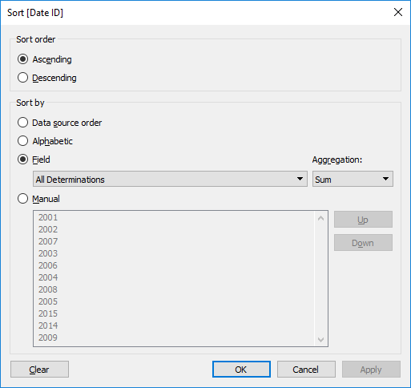

NOTE For an example of a complete solution to this practice, see **Sorting_Solution.twb.**